Vessel specs and details

This information is being provided in response to condition 3.1.2 of the Moray Offshore Windfarm (East) Limited (Moray East) Wind Farm and OfTI Marine Licences and condition 3.1.3 of the Moray East OSP Marine Licence.
“The Licencee must ensure that prior to their engagement in the Licensable Marine Activity authorised under this licence, the name and function of any vessel, vehicle, agent, contractor or sub-contractor appointed to engage in the Works and, where applicable, the master’s name, vessel type, vessel IMO number and vessel owner or operating company, are fully detailed in the Vessel Report and the Persons Acting on Behalf of the Licencee Reports available on the Moray East Offshore Wind Farm, Keeping Mariners Informed webpage, which can be found at: http://www.morayoffshore.com/moray-east/the-project/notices-to-mariners/.
Any changes to the supplied details must be uploaded to the Vessel Report and the Persons Acting on Behalf of the Licencee Report and the Licensing Authority must be notified, in writing, prior to any vessel, agent, contractor or sub-contractor which has not yet been notified to the Licensing Authority engaging in the Licensable Marine Activity.
Only those vessels, agents, contractors, or sub-contractors detailed in the Vessel Report and the Persons Acting on Behalf of the Licencee Report are permitted to carry out any part of the Works. […]”

Relevant Moray East Marine Licences: Wind Farm (Stevenson MS-00009425, MacColl MS-00009424, Telford MS-00009426), OfTI (MS-00009423) and OSP (06347/19/0) Marine Licences.

Vessel Name | Vessel Type /  Function | Operator | Contact Details  (Where applicable) | Vessel ID | Vessel key  characteristics | Date on site | Relevant  Marine Licence
SEACAT WEATHERLY  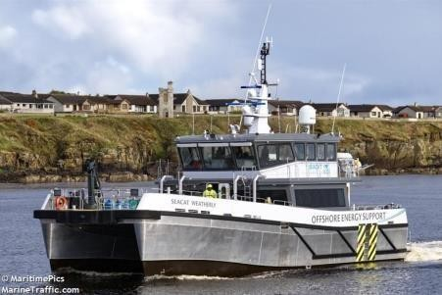 | O&M  Crew Transfer Vessel (CTV)  High Speed Craft | Seacat | Email  weatherly@seacatservices.co.uk  Tel.IP: +44 1983 410727  Mobile : 07476 288320 | Call Sign:  MHXT7  MMSI:  232029215 | LOA: 23.9m  Beam: 8.7m  Draught: 1.3m | From 01/10/2021 | Wind  Farm Marine Licence

Vessel Name | Vessel Type /  Function | Operator | Contact Details  (Where applicable) | Vessel ID | Vessel key  characteristics | Date on  site | Relevant  Marine Licence
FARRA CLIONA  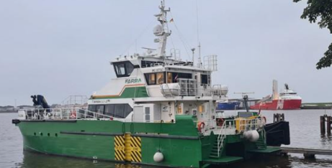 | Project  Crew Transfer Vessel (CTV)  High Speed Craft | FARRA | Email  Operations@farramarine.com  Tel – 07596 152567 | Call Sign:  MNDD9  MMSI:  232046092 | LOA: 27m  Beam: 9 m  Draught: 1.4m | From 08/02/2024 | Wind Farm Marine License

Vessel Name | Vessel Type /  Function | Operator | Contact Details  (Where applicable) | Vessel ID | Vessel key  characteristics | Date on  site | Relevant  Marine Licence
ESVAGT ALBA  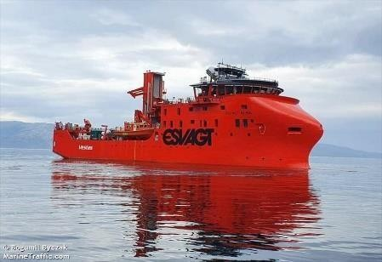 | O & M  Service Operation Vessel (SOV) | Esvagt | Email  alba@esvagtvessel.com  Tel.IP: +45 82136240  Mobile: +45 53650831 | Call Sign:  OYEI2  IMO:  9878979  MMSI:  219026495 | LOA: 70m  Beam: 17m  Draught 5.4m | From 02/07/2021 | Wind Farm Marine Licence
ESVAGT WIND 8  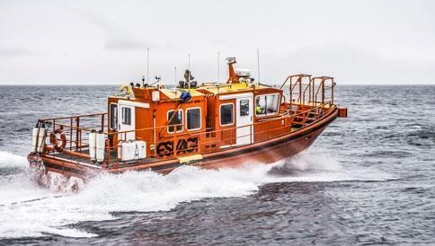 | O&M Esvagt Alba  Daughter craft  High Speed Craft | Esvagt | Email  alba@esvagtvessel.com  Tel.IP: +45 82136240  Mobile : +45 53650831 | Call Sign:  OX3134  MMSI:  219027647 | LOA: 13m  Beam: 4m  Draught: 1m | From 02/07/2021 | Wind Farm Marine Licence

Vessel Name | Vessel Type /  Function | Operator | Contact Details  (Where applicable) | Vessel ID | Vessel key  characteristics | Date on  site | Relevant  Marine Licence
FARRA EITHNE  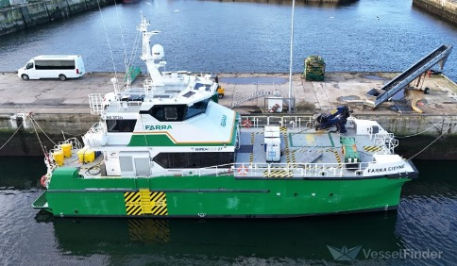 | Project  Crew Transfer Vessel (CTV)  High Speed Craft | FARRA | Email  Farraeithne@farramarine.com  Tel – 07517 611432 | Call Sign:  MOJK39  MMSI:  232050960 | LOA: 27m  Beam: 9 m  Draught: 1.7m | From 06/03/2024 | Wind Farm Marine License

Vessel Name | Vessel Type /  Function | Operator | Contact Details  (Where applicable) | Vessel ID | Vessel key  characteristics | Date on  site | Relevant  Marine Licence
MANOR VULCAN  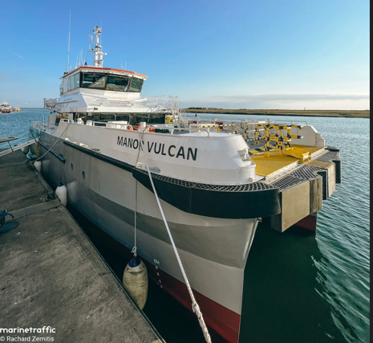 | Project  Crew Transfer Vessel (CTV)  High Speed Craft | Manor | Email  vulcan@oegrenewables.com  Tel – 07709 288754 | Call Sign:  MLRK6  MMSI:  232042488 | LOA: 27.1m  Beam: 8.9 m  Draught: 1.72m | From 12/04/2024 | Wind Farm Marine License

Vessel Name | Vessel Type /  Function | Operator | Contact Details  (Where applicable) | Vessel ID | Vessel key  characteristics | Date on  site | Relevant  Marine Licence
MANOR PRESTO  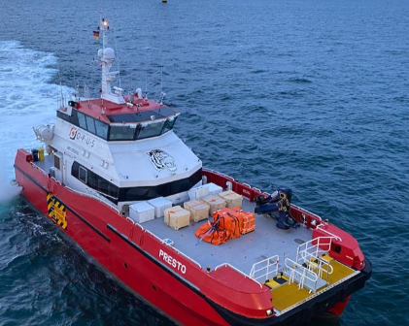 | Project  Crew Transfer Vessel (CTV)  High Speed Craft | Manor | Email  presto@oegrenewables.com  Tel – +49 162 253 5545 | Call Sign:  MROV6  MMSI:  9782132 | LOA: 27.1m  Beam: 8.9 m  Draught: 1.5m | From 17/04/2024 | Wind Farm Marine License

Vessel Name | Vessel Type /  Function | Operator | Contact Details  (Where applicable) | Vessel ID | Vessel key  characteristics | Date on  site | Relevant  Marine Licence
GEO SURVEYOR  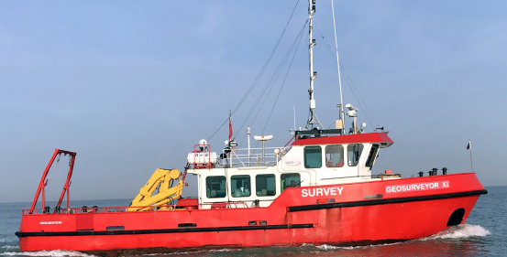 | Project  Multicat | GEOxyz | Email  Geosurveyor11@geoxyz.eu  Tel –  +31 681131956  +34 744 45 5638 | Call Sign:  2GRS3  MMSI:  3080192 | LOA: 21.1m  Beam: 6.4 m  Draught: 2.2m | From 27/04/2024 | Wind Farm Marine License

